**School of Computing**

**6006CEM Machine Learning and Related Applications**

**Assignment Brief August 2023**

|  |  |  |  |  |
| --- | --- | --- | --- | --- |
| Module Title  Machine Learning and Related Applications | Individual | | Cohort - AUG | Module Code  **6004CEM** |
| Coursework Title (e.g. CWK1) Report  Portfolio | | | | Hand out date:  21/08/2023 |
| Lecturers  Vasuky Mohanan | | | | Due date:  **27/11/2023** |
|  | | Coursework type  Practical work | | % of Module Mark  100% |

Module Learning Outcomes Assessed:

1. Apply the knowledge behind the principles, techniques and applications of machine learning
2. Critically evaluate existing machine learning methods and select the most appropriate ones for a certain task
3. Analyse information, compare different machine learning techniques and produce an academic written report as a result
4. Conceptualise the role of modern machine learning approaches and their impact on society

# Scenario

This assessment is designed to allow you to demonstrate your understanding of machine learning and your ability to use different machine learning techniques, from selecting a suitable dataset(s), analysing and pre-processing the data, to creating, evaluating and optimising machine learning models.

In particular, you will be selecting a machine learning classification problem of your choice and applying different machine learning algorithms and methods to solve the selected problem.

Beside the application and implementation of different techniques, it is your understanding, analysis and evaluation on the suitability of the applied techniques and project conduct will gain you mark. For more details, see the marking scheme at the end of this document.

# Task 1

Your first task consists of the following:

1. selecting a real-world **classification** problem,
2. selecting suitable dataset(s) for the chosen problem,
3. selecting more than one appropriate Machine Learning algorithm for implementation of the models,
4. evaluating the created models on the selected data, and
5. tuning the models to achieve better performance.

## Notes:

1. If it is your **re-sit**, you must choose a **different** problem and dataset(s) from the selected problem and dataset(s) in the previous attempt(s).
2. You should choose a dataset that allows you to demonstrate your ability to perform data analysis and pre-processing techniques such as handling missing, categorical, non-numeric values, duplicates, outliers, scaling, etc. The selected dataset, **after** pre-processing, must contain **at least 1000** samples and cannot be one of toy scikit-learn or synthetic datasets.
3. You can use learnt/existing algorithms or combine some of them or even come up with a new algorithm of your own.

# Task 2

For the second task, a viva to evaluate your understanding of the implementation. This will be followed by a question and answers session.

## Notes:

1. The viva will be for **7 mins**.
2. You are NOT required to walk through every line of the source code, but the execution of all stages and their corresponding outputs of the source code.
3. This will be followed by a 3 min Q &A

# Task 3

Your next task is to write a report (maximum 2000 words) based on the technical work involving:

* 1. Analysing and pre-processing the data,
  2. Applying different algorithms and methods to build learning models,
  3. Making appropriate adjustments to improve the models’ performance,
  4. Evaluating the results,
  5. Comparing to the approaches and results of other existing works on the same problem

## Notes:

1. Your report should focus on how actually algorithms/methods/techniques are applied or developments that are novel and specific to your work rather than how they work theoretically.
2. Your report should include appropriate outcomes such as data analysis diagrams, outcomes from the models, code snippets, etc. to support your text.
3. Include all your source code as text in Appendix B at the end of the report. **Do not** use screenshots of your code in Appendix B. Your code should be presented as text.
4. The 2000 words limit is the absolute maximum word count for the whole report. Assignments that are more than 10% over the word limit will result in a deduction of 10% of the mark i.e. a mark of 60% will lead to a reduction of 6% to 54%. The word limit includes quotations, but excludes the (GitHub, datasets, OneDrive) URLs, bibliography, reference list, and appendices.

# Task 4

Submission of your coursework is in form of a single **Word** file through **Canvas**.

1. the source code with appropriate comments

Marking Scheme

|  |  |  |
| --- | --- | --- |
|  | **Assessment Criteria** | **Mark** |
| 1 | **Required components**   * Source-code (with appropriate comments, correct format and commit) * Viva | /15 |
| 2 | **Introduction**   * Problem statement * Existing approaches or methods and their results * Similarities and differences between your work and the existing works | /20 |
| 3 | **Implementation**   * Data analysis * Data pre-processing * Applied machine learning algorithms * Model tuning * Evaluation (metrics, cross-validation, confusion matrixes etc.) | /40 |
| 4 | **Result**   * Analysis and evaluation * Conclusion | /15 |
| 5 | **Presentation**   * Logical structure with clear and appropriate sections and subsections * Appropriate and consistent format and representation * Correct references (datasets, models, figures, etc.) and in-text citations * Good scientific/academic writing * Complete source code as text at Appendix B | /10 |
| **Sub total** | | **/100** |
| 7 | **Word count** (deduction for over 2000 word limit) | **-** |
| **Total** | | **/100** |

General Notes:

* 1. You are expected to use the APA style for referencing.
  2. The University cannot take responsibility for any coursework lost or corrupted on disks, laptops or personal computer. Students should therefore regularly back-up any work and are advised to save it on the University system.
  3. If there are technical or performance issues that prevent submitting coursework through the online coursework submission system on the day of a coursework deadline, an appropriate extension to the coursework submission deadline will be agreed. This extension will normally be 24 hours or the next working day if the deadline falls on a Friday or over the weekend period. This will be communicated via your Module Leader.
  4. You are encouraged to check the originality of your work by using the draft Turnitin links on Canvas.
  5. Collusion between students (where sections of your work are similar to work submitted by other students in this or previous module cohorts) is taken extremely seriously and will be reported to the academic conduct panel. This applies to both coursework and exam answers.
  6. You must not submit work for assessment that you have already submitted (partially or in full), either for your current course or for another qualification of this university, with the exception of resits, where for the coursework, you maybe asked to rework and improve a previous attempt. This requirement will be specifically detailed in your assignment brief or specific course or module information. Where earlier work by you is citable, i.e. it has already been published/submitted, you must reference it clearly. Identical pieces of work submitted concurrently may also be considered self-plagiarism.

# Mark allocation guidelines to students

|  |  |  |
| --- | --- | --- |
| **Mark band** | **Outcome** | **Guidelines** |
| 90-100%  1st | Meets learning outcomes | 1st - Exceptional work with very high degree of understanding, creativity and critical/analytic skills. Evidence of exceptional research well beyond minimum recommended using a range of methodologies. Exceptional understanding of knowledge and subject-specific theories. Demonstrates creative flair, a high degree of originality and autonomy.  Exceptional ability to apply learning resources. Demonstrates well-developed problem-solving skills. Work completed with very high degree of accuracy and proficiency and autonomy. Exceptional communication and expression, significant evidence of  professional skill set. Student evidences deployment of a full range of exceptional technical and/or artistic skills. |
| 80-89%  1st | 1st - Outstanding work with high degree of understanding, creativity and critical/analytical skills. Outstanding understanding of knowledge and subject-specific theories. Evidence of outstanding research well beyond minimum recommended using a range of methodologies. Demonstrates creative flair, originality and autonomy.  Outstanding ability to apply learning resources. Demonstrates clear problem-solving skills. Assessment completed with high degree of accuracy and proficiency and high-level of autonomy. Outstanding communication and expression, evidence of  professional skill set. Student evidences deployment of a full range of technical and/or artistic skills. |
| 70-79%  1st | 1st - Excellent work with clear evidence of understanding, creativity and critical/analytical skills. Thorough research well beyond the minimum recommended using methodologies beyond the usual range. Excellent understanding of knowledge and subject- specific theories with evidence of considerable originality and autonomy.  Excellent ability to apply learning resources. Demonstrates consistent, coherent substantiated argument and interpretation. Demonstrates considerable creativity and clear problem-solving skills. Assessment completed with accuracy, proficiency, and  considerable autonomy. Excellent communication and expression, some evidence of professional skill set. Student evidences deployment of a highly developed range of technical and/or artistic skills. |
| 60-69%  2:1 | 2:1 - Very good work demonstrating strong understanding of theories, concepts and issues with clear critical analysis. Thorough research, using established methodologies accurately, beyond the recommended minimum with little, if any, irrelevant material present. Very good understanding, evidencing breadth and depth, of knowledge and subject-specific theories with some originality and autonomy.  Very good ability to apply learning resources. Demonstrates coherent substantiated argument and interpretation. Demonstrates some originality, creativity and problem-solving skills. Work completed with accuracy, proficiency, and autonomy. Very good  communication and expression with evidence of professional skill set. Student has a thorough command of a good range of technical and/or artistic skills. |
| 50-59%  2:2 | 2:2 - Good understanding of relevant theories, concepts and issues with some critical analysis. Research undertaken accurately using established methodologies, enquiry beyond that recommended may be present. Some errors may be present and some |

|  |  |  |
| --- | --- | --- |
|  |  | inclusion of irrelevant material. Good understanding, with evidence of breadth and depth, of knowledge and subject-specific theories with indications of originality and autonomy.  Good ability to apply learning resources. Demonstrates logical argument and interpretation with supporting evidence. Demonstrates some originality, creativity and problem-solving skills but with inconsistencies. Expression and presentation mostly accurate, proficient, and conducted with some autonomy. Good communication and expression with appropriate professional  skill set. Student consistently demonstrates a well-developed range of technical and/or artistic skills. |
| 40-49%  3rd Class | 3rd - Meet the learning outcomes with a basic understanding of relevant theories, concepts and issues. Demonstrates an understanding of knowledge and subject-specific theories sufficient to deal with concepts. Assessment may be incomplete and with some errors. Research scope sufficient to evidence use of some established methodologies. Some irrelevant material likely to be present.  Basic ability to apply learning resources. Demonstrates ability to devise and sustain an argument. Demonstrates some originality, creativity and problem-solving skills but with inconsistencies. Expression and presentation sufficient for accuracy and proficiency.  Sufficient communication and expression with basic professional skill set. Student demonstrates technical and/or artistic skills. |
| 30-39%  Fail | Fails to achieve learning outcomes | Fail – Very limited understanding of relevant theories, concepts and. Little evidence of research and use of established methodologies. Some relevant material will be present. Deficiencies evident in analysis. Fundamental errors and some misunderstanding likely to be present.  Limited ability to apply learning resources. Student’s arguments are weak and poorly constructed. Very limited originality, creativity, and struggles with problem-solving skills. Expression and presentation insufficient for accuracy and proficiency. Insufficient communication and expression and with deficiencies in professional skill set. Student demonstrates some  deficiencies in technical and/or artistic skills. |
| 20-29%  Fail | Fail - Clear failure demonstrating little understanding of relevant theories, concepts and issues. Minimal evidence of research and use of established methodologies and incomplete knowledge of the area. Serious and fundamental errors and aspects missing Little evidence of ability to apply learning resources. Student’s arguments are very weak and with no evidence of alternative views. Little evidence of originality, creativity, and problem-solving skills. Expression and presentation deficient for accuracy and proficiency. Insufficient communication and expression and with deficiencies in professional skill set. Student demonstrates a  lack of technical and/or artistic skills. |
| 0-19%  Fail | Fail - Inadequate understanding of relevant theories, concepts and issues. Complete failure, virtually no understanding of requirements of the assignment. Material may be entirely irrelevant. Assessment may be fundamentally wrong, or with major elements missing. Not a serious attempt. No evidence of research.  Inadequate evidence of ability to apply learning resources. Very weak or no evidence of originality, creativity, and problem- solving skills. Students presents no evidence of logical argument and no evidence of alternative views. Expression and  presentation extremely weak for accuracy and proficiency. Communication and expression very weak and with significant deficiencies in professional skill set. Student evidences few or no technical and/or artistic skills |

**Table of Contents**

Scenario 2

Task 1 2

Notes: 2

Task 2 2

Notes: 2

Task 3 3

Notes: 3

Task 4 3

Mark allocation guidelines to students 6

Introduction 12

Implementation 15

Result 20

Figure 7: Result of the analysis of the dataset…………………………………………………………………………………20

Figure 8: Continuation of the dataset analysis 21

Figure 9: The Accuracy of algorithm and confusion matrix 21

Figure 10: Classification report 22

Figure 11 & 12: Display of all the accuracy of the 4 algorithms used 22

References 27

Appendix 28

# Introduction

The increasing prevalence of fraudulent activities poses a significant threat to the financial stability and integrity of businesses. In the context of this challenge, the problem at hand is to develop an effective fraud detection system using machine learning classification techniques. The objective is to build models that can accurately identify and flag potentially fraudulent transactions within a financial dataset.

The complexity of this problem arises from the evolving nature of fraud schemes, where perpetrators constantly adapt to evade detection. The dataset chosen for this problem includes transactional information such as transaction amounts, timestamps, merchant details, and user profiles. The challenge is to train models that can generalize well to new and emerging fraud patterns, providing a robust defense against fraudulent activities.

**Rule-Based Systems:**

Traditional rule-based systems involve defining a set of rules to flag transactions based on specific criteria. For example, setting rules for unusual transaction amounts, frequent transactions, or transactions from unfamiliar locations.

Results: While rule-based systems are interpretable and straightforward, they often struggle to adapt to evolving fraud patterns, as rule updates are manual and may lag behind emerging threats.

**Similarities:**

**Similarities with Rule-Based Systems:**

**Interpretability:** Decision trees, and to some extent, Random Forests and Naive Bayes, offer interpretability by expressing decisions in a rule-like format. This is similar to rule-based systems where decisions are explicitly defined by a set of rules.

**Decision Criteria:** All the mentioned classifiers, including rule-based systems, operate based on decision criteria. While the complexity and nature of these criteria may differ, they all involve making decisions based on certain conditions.

**Transparent Decision Logic:** Decision trees and rule-based systems share the characteristic of having a transparent decision logic. It is easier to understand how a specific decision is reached by examining the rules or the branches in a decision tree.

**Applicability in Specific Contexts:** Rule-based systems and certain classifiers, like Naive Bayes, may work well in scenarios where specific rules or probabilities can adequately capture the underlying patterns.

**Differences:**

**Learning Approach:**

**Machine Learning Classifiers:** Decision trees, Random Forests, Naive Bayes, and Neural Networks are machine learning models that learn from data. They adapt their decision criteria based on patterns observed in the training data. The learning process involves adjusting model parameters to optimize performance on the given task.

**Rule-Based Systems:** Rule-based systems, on the other hand, rely on explicitly defined rules that are often crafted by domain experts. The rules are predetermined and do not adapt to new patterns in the data automatically. Updates to the rule set usually require manual intervention.

**Adaptability to Complex Patterns:**

**Machine Learning Classifiers:** These models are capable of capturing complex relationships and patterns in data, especially in high-dimensional spaces. They can adapt to non-linear decision boundaries and learn intricate dependencies between features.

**Rule-Based Systems:** Rule-based systems may struggle to adapt to complex or non-linear patterns that are not explicitly defined in the rule set. They might miss out on capturing subtle interactions between features that machine learning models can learn.

**Handling of Uncertainty:**

**Machine Learning Classifiers:** These models can inherently handle uncertainty by providing probabilistic predictions. For instance, in Naive Bayes, the output includes probabilities associated with each class. Neural networks can also provide uncertainty estimates, especially in Bayesian variants.

**Rule-Based Systems:** Rule-based systems often lack a built-in mechanism to express or handle uncertainty. The rules are deterministic, and if uncertainty is considered, it needs to be explicitly incorporated into the rule set.

# Implementation

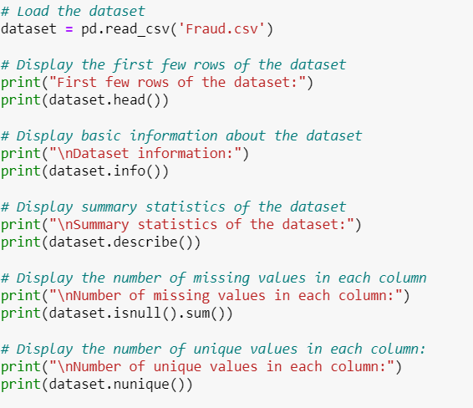

**Figure 1: Data Analysis**

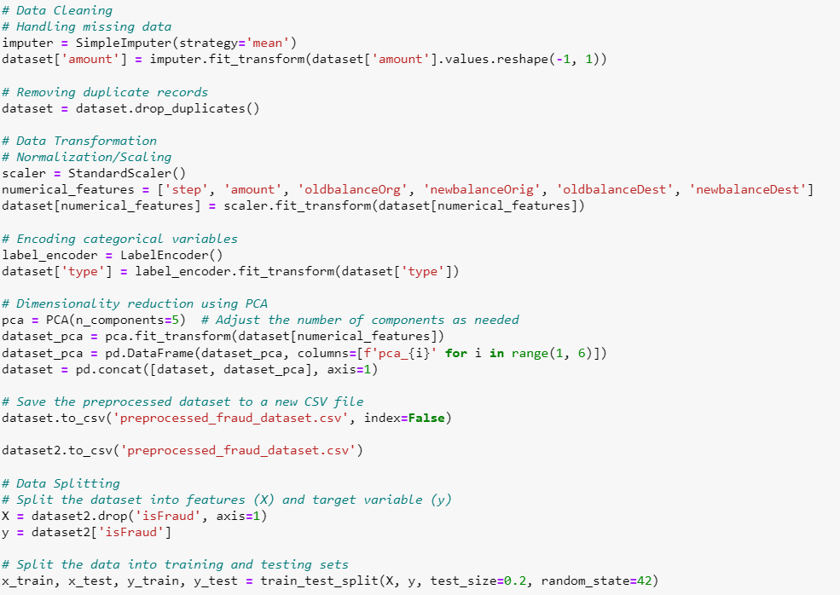

**Figure 2: Data Preprocessing**

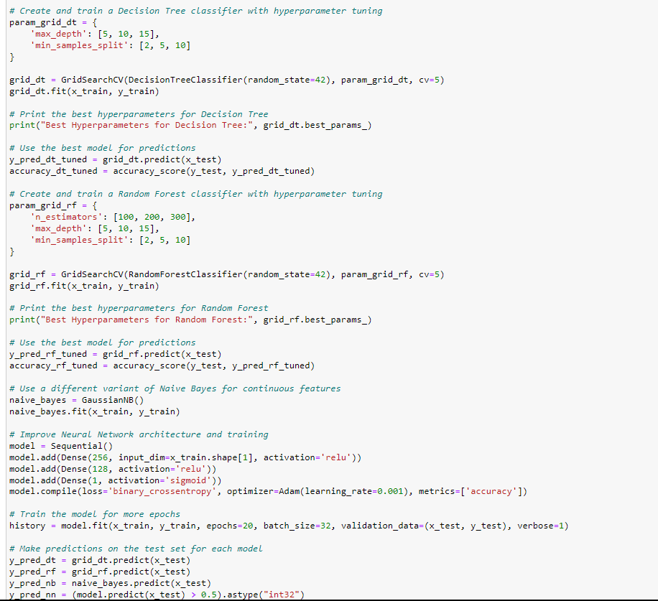

**Figure 3: Model Tuning**

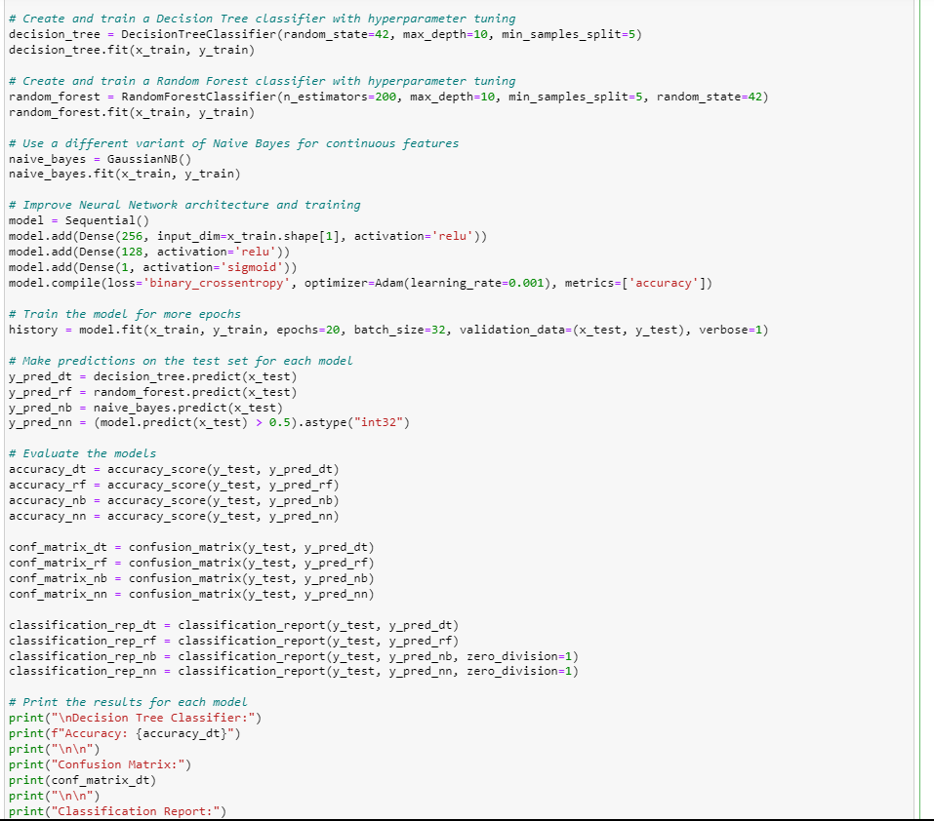

**Figure 4: Applied machine algorithm**

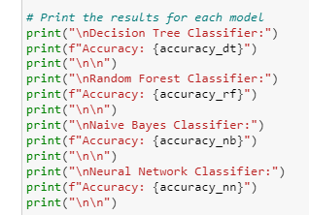

**Figure 5: Printing of the result of the machine algorithm**

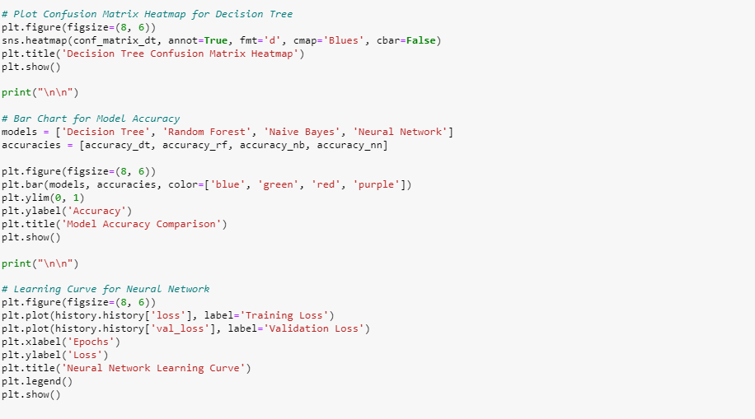

**Figure 6: Evaluation**

# Result

# Figure 7: Result of the analysis of the dataset

# Figure 8: Continuation of the dataset analysis

# 

# Figure 9: The Accuracy of algorithm and confusion matrix

# 

# Figure 10: Classification report

# Figure 11 & 12: Display of all the accuracy of the 4 algorithms used

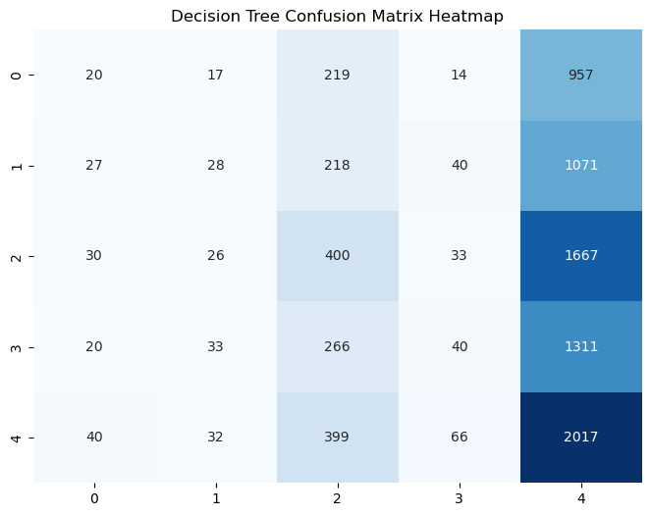

**Figure 13: Decision Tree Confusion Matrix**

**Figure 14: Graph of Model Accuracy**

**Figure 15: Learning curve of the Neural Network**

**Conclusion**

In summary, the comparison of machine learning classifiers (Decision Trees, Random Forests, Naive Bayes, Neural Networks) and rule-based systems highlights a spectrum of approaches in fraud detection.

Machine learning classifiers, driven by data, offer adaptability to complex patterns and handle uncertainty well. Their probabilistic nature allows nuanced insights into fraud detection. In contrast, rule-based systems provide transparency and interpretability but may lack adaptability to evolving patterns.

The choice depends on specific requirements. For complex, dynamic scenarios, machine learning classifiers excel, while rule-based systems are effective in situations where interpretability and explicit rules are paramount. The continuous integration of diverse approaches contributes to the ongoing enhancement of fraud detection systems.

# References

* (No date) *Learning to CITE framework: How to automatically construct citations ...* Available at: <https://www.researchgate.net/publication/303702301_Learning_to_Cite_Framework_How_to_Automatically_Construct_Citations_for_Hierarchical_Data> (Accessed: 24 November 2023).
* *Rules-based fraud detection* (2023) *Fraud.net*. Available at: <https://fraud.net/d/rules-based-fraud-detection/> (Accessed: 24 November 2023).
* Breiman, L., & Friedman, J. H. (1997). Classification and regression trees. Wadsworth Publishing Company.
* Duda, R. O., Hart, P. E., & Stork, D. G. (2012). Pattern classification. John Wiley & Sons.
* Goodfellow, I., Bengio, Y., & Courville, A. (2016). Deep learning. MIT press.
* Russell, S. J., & Norvig, P. (2010). Artificial intelligence: A modern approach. Pearson Education.

# Appendix